Oculus Store UI Ideas

Current Store Layout

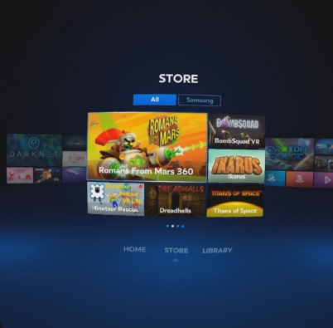  
  
  
  
  
  
  
  
  
  
  
  
  
  
  
  
  
  
Swipe left or right to see more games

Our ideas:

* Have multiple categories like the non-gear vr version of the app.
* Layout the oculus store like our milk vr interface

Categories

* 360 Video (Milk VR) – Link back to the milk vr menu
* Action
  + Shooter, fighting, rpg, horror
* Sports
  + Racing, Football, soccer, basketball, baseball, etc.
* Strategy
  + Puzzle, battle
* Simulation
  + Exploration
  + Rollercoaster
* Casual
  + Card
  + Board
* Educational

The categories could be grouped and divided into sub categories as shown above in order to cut down on the amount of categories in any one view.

The home screen will be laid out like the Milk VR menu, with planets as categories, and a galaxy icon to get back to the Milk VR home.

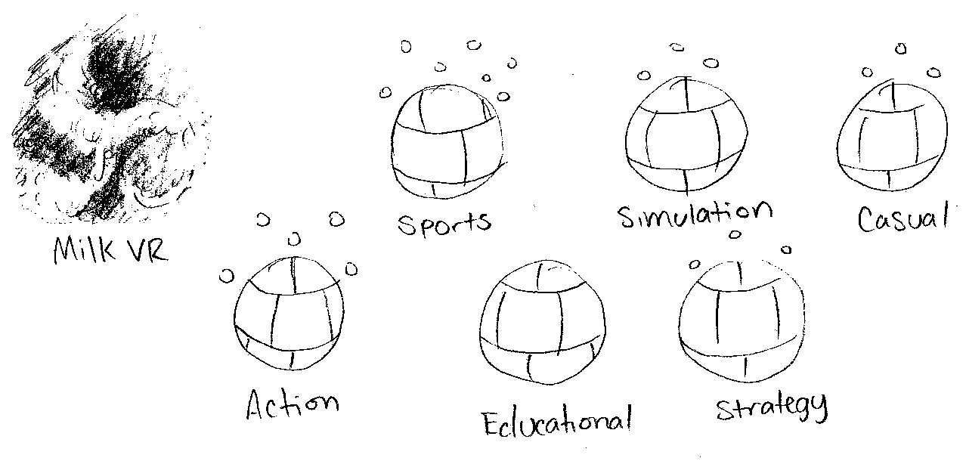For the planets we could texture them with thumbnails of games in the represented category in order to cut down on modeling and display the category name below each planet.

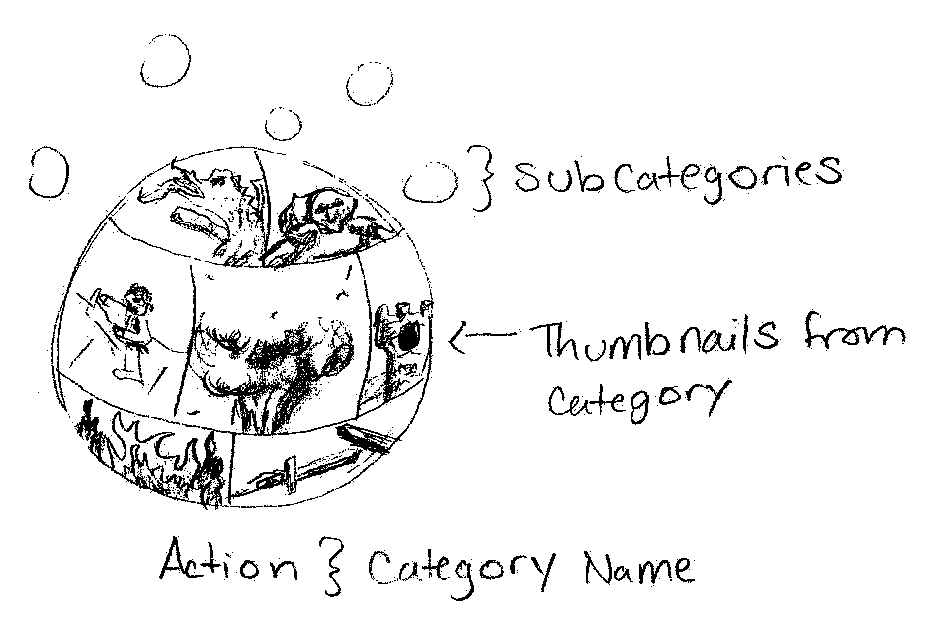

When you travel to a planet with sub categories you will see a menu similar to the home screen.

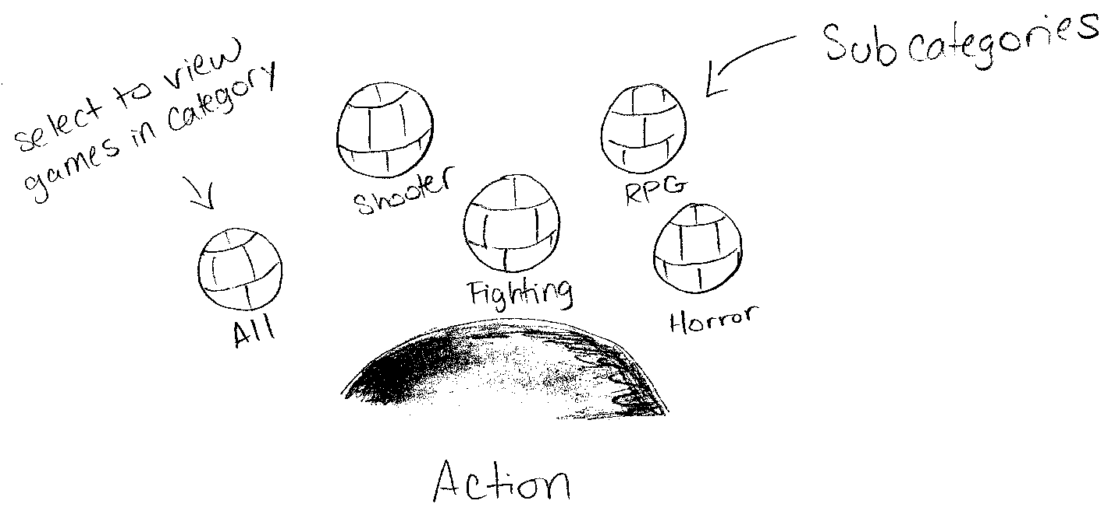After traveling to the chosen category we can display the thumbnails on a screen in front of the user, and allow options to sort by top selling, most liked, and newest. We could also allow users to choose for the games to be displayed in ascending or descending order. The user could then scroll up and down to view more apps.

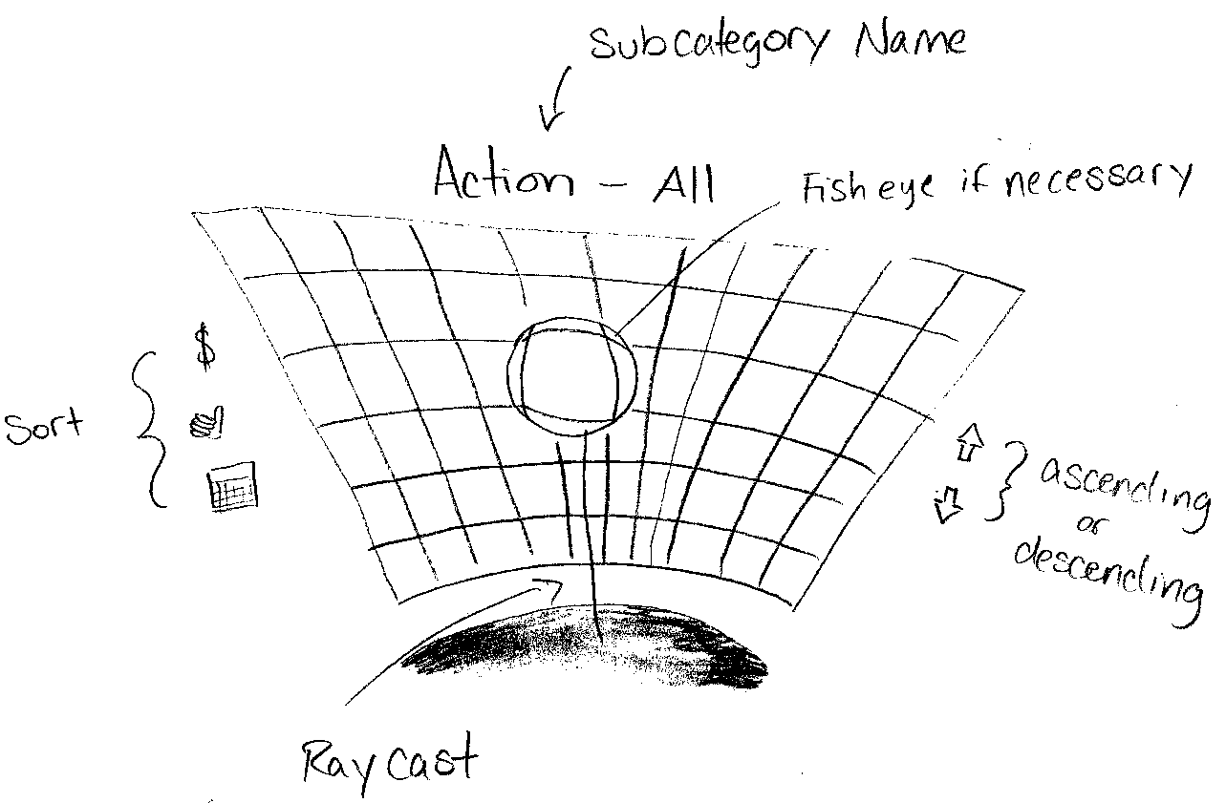

Depending on the number of thumbnails we choose to show at a time we may need to use a fish eye type of selection like the professor suggested so that users can both get a closer look at the thumbnail and select a specific thumbnail easier.